Pre-embedded field-mountable optical fiber connector
FMCSC-D type
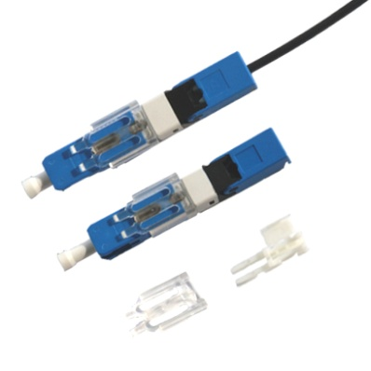
Product Introduction
For Field-mountable Optical Fiber Connectors, the SC type connectors are compliant with Telcordia GR-326-CORE. The Interface dimensions conform to industry standards and IEC standards.

Features
- SC connector type, UPC and APC polishing
- Precise alignment of V type groove
- Snap lock structure
- Low insertion loss, high return loss
- Superior repeatability, high stability and reliability

Applications
- FTTx
- Reconstruction the cable line of the computer room

Standards
- YD/T 1272.3-2015, YD/T 2341.1-2011
- IEC 61754-4 2013
- GR-1081-CORE

Specifications
Specification | Unit | Parameter
Cable type | mm | 3.0x2.0 Bow-type drop cable
Cladding diameter | μm | 125(652 & 657)
Fiber diameter | um | 250μm
Optical fiber mode | — | Single mode
Insertion loss | dB | ≤ 0.30(1310nm & 1550nm)
Return loss | dB | ≤ -50
Operation time | s | 15s(Processing optical fiber time is not included)
Success rate | — | >98%
Assembly times | times | >10
Bare fiber retention | N | >5
Tensile strength | N | >50
Operating temperature | ℃ | -40～+80
Online pull test(20 N) | dB | △ IL ≤ 0.2dB
V groove clamping force variety(4N/30s) | dB | △ IL ≤ 0.2dB
Mechanical durability(500times) | dB | △ IL ≤ 0.2dB
4m Drop test(3 times) | dB | △ IL ≤ 0.2dB
Vibration test(10~55Hz two hours in three direction) | dB | △ IL ≤ 0.2dB
High temperature test(85℃, 2000hours) | dB | △ IL ≤ 0.2dB
Temperature cycle test(-40~85℃, 500cycles) | dB | △ IL ≤ 0.2dB
Humidity test(85℃, 85%RH, 2000hours) | dB | △ IL ≤ 0.2dB

Ordering information
OFC-FMC- -----
Connect Pots：SP:Single connection point,MP:Multi connection point
Fiber/Cable Type：025:250um,09:900um,20:2.0mm, 30:3.0mm,CD:3.0*2.0 Bow-type drop cable
Endface：PC,UPC,APC
Connector：FCP:FC plug,FCS:FC socket,SCP:SC plug,SCS:SC socket,LCP:LC plug,LCS:LC socket
Fiber Type：S:G.652, A1:G.657A1,A2:G.657A2, M:50/125,D62.5/125
FMC Type：MC:Mechanical type buckle locking, MS:Mechanical thread locking,F:Fusion splice type,EP:Endface pre-melted
FMC：(Field-Mountable Optical Fiber Connector)
Pre-embedded field-mountable optical fiber connector
FMCSC-PLW type
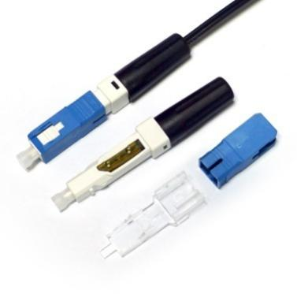
Product Introduction
For Field-mountable Optical Fiber Connectors, the SC type connectors are compliant with Telcordia GR-326-CORE. The Interface dimensions conform to industry standards and IEC standards.

Features
- SC connector type, UPC polishing
- Precise alignment of V type groove
- Thread locking structure
- Low insertion loss, high return loss
- Superior repeatability, high stability and reliability

Applications
- FTTx
- Reconstruction the cable line of the computer room

Standards
- YD/T 1272.3-2015, YD/T 2341.1-2011
- IEC 61754-4 2013
- GR-1081-CORE

Specifications
Specification | Unit | Parameter
Cable type | mm | 3.0x2.0 Bow-type drop cable, 2.0&3.0 indoor cable
Cladding diameter | μm | 125(652 & 657)
Fiber diameter | um | 250μm
Optical fiber mode | — | Single mode
Insertion loss | dB | ≤ 0.30(1310nm & 1550nm)
Return loss | dB | ≤ -50
Operation time | s | 15s(Processing optical fiber time is not included)
Success rate | — | >98%
Assembly times | times | >10
Bare fiber retention | N | >5
Tensile strength | N | >50
Operating temperature | ℃ | -40～+80
Online pull test(20 N) | dB | △ IL ≤ 0.2dB
V groove clamping force variety(4N/30s) | dB | △ IL ≤ 0.2dB
Mechanical durability(500times) | dB | △ IL ≤ 0.2dB
4m Drop test(3 times) | dB | △ IL ≤ 0.2dB
Vibration test(10~55Hz two hours in three direction) | dB | △ IL ≤ 0.2dB
High temperature test(85℃, 2000hours) | dB | △ IL ≤ 0.2dB
Temperature cycle test(-40~85℃, 500cycles) | dB | △ IL ≤ 0.2dB
Humidity test(85℃, 85%RH, 2000hours) | dB | △ IL ≤ 0.2dB

Ordering information
OFC-FMC- -----
Connect Pots：SP:Single connection point,MP:Multi connection point
Fiber/Cable Type：025:250um,09:900um,20:2.0mm, 30:3.0mm,CD:3.0*2.0 Bow-type drop cable
Endface：PC,UPC,APC
Connector：FCP:FC plug,FCS:FC socket,SCP:SC plug,SCS:SC socket,LCP:LC plug,LCS:LC socket
Fiber Type：S:G.652, A1:G.657A1,A2:G.657A2, M:50/125,D62.5/125
FMC Type：MC:Mechanical type buckle locking, MS:Mechanical thread locking,F:Fusion splice type,EP:Endface pre-melted
FMC：(Field-Mountable Optical Fiber Connector)

